Locality Boundary Tool: SOP
What is the tool used for?
This tool is intended to help analysts create best fit 2022 locality boundaries and compare their proposed boundaries to the 2011 locality boundaries. The tool takes a list of 2022 datazones assigned (by the analyst) to localities and compares these localities to the 2011 localities. It allows the user to flick between 2011 & 2022 DZs and IZs, the 2011 localities and the new proposed boundaries. It also highlights areas that have moved to a new locality under the new locality proposal.

Where can I find the tool?
The tool can be found on GitHub: Public-Health-Scotland/LIST-Locality-Boundary-Drawing-Tool
Make sure you are on the main branch before attempting to use the tool.
There is also a copy of the code in the West Hub Geospatial folder, in case you are unable to access Github: \\Isdsf00d03\LIST_analytics\West Hub\Geospatial Cross Team\2022 Datazone to HSCP Locality Lookups\2022 Locality Proposal Tool
NOTE: DO NOT make any changes to the code in the west hub folder. There is an explanation of how to make a copy in your own folder later on.

Is there anything I need to install before using this code?
The following packages are used within the code:
- shiny
- flexdashboard
- shinydashboard
- DT
- shinycssloaders
- leaflet.extras
- flextable
- tidyverse
- readxl
- phsmethods
- phsstyles
- shinyWidgets
- sf
- fs
Make sure you have all of these packages installed before running the code. You can install these using the install.packages function e.g. install.packages(“phsstyles”)

Anything else to note before using the tool?
The only thing to note is that this tool assumes that the new localities you wish to create are based on 2022 datazones. Your new localities will be groups of 2022 datazones. You can follow intermediate zone boundaries if you would like when creating your boundaries but this tool only allows you to group up datazones in your input sheet.

How do I get a copy of the code?
To use the tool you first have to either:
- Create a clone from GitHub
- Create a copy of the code in the West Hub folder

Create a Clone from Github
Refer to GitHub guidance. Make sure you are on the main branch and pull the latest updates to the branch before running.
Guidance: LIST-examples/Git-and-GitHub at main · Public-Health-Scotland/LIST-examples
Copy the Code From The West Hub Folder
Navigate to the following folder in your files pane in Rstudio: \\Isdsf00d03\LIST_analytics\West Hub\Geospatial Cross Team\2022 Datazone to HSCP Locality Lookups\
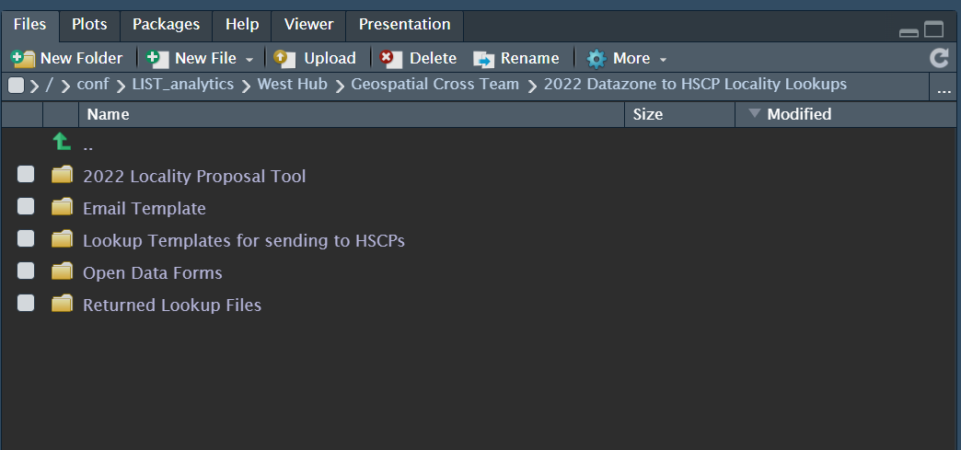
Once you are in this folder, click on the white box next to the 2022 Locality Proposal Tool folder.
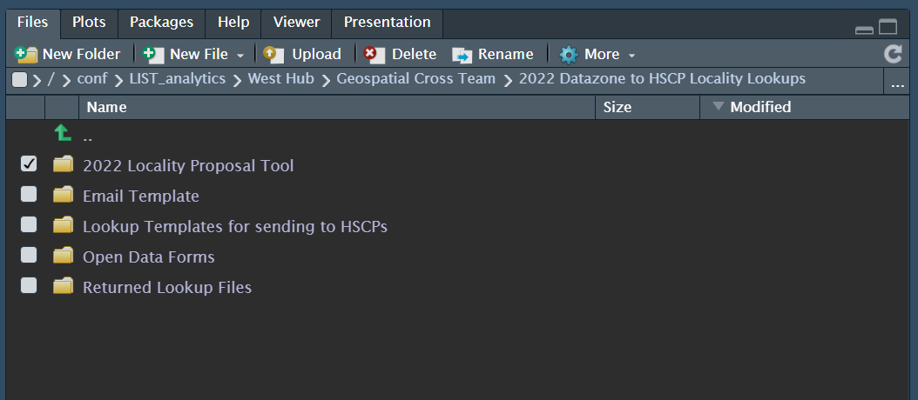
Now click on the 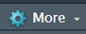 symbol and press Copy To…
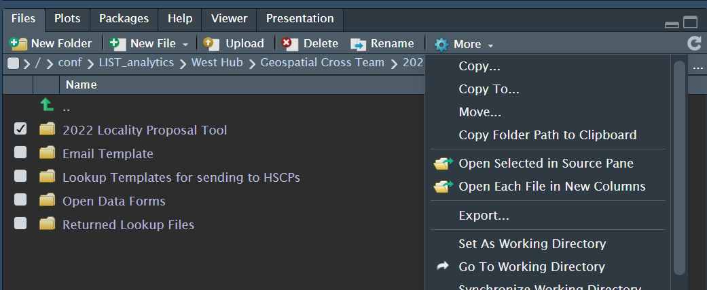

The following box will appear.
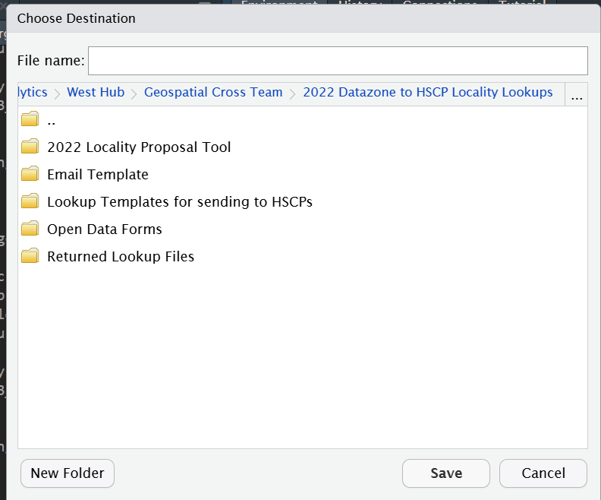

Now navigate to the folder where you want your copy of the code to be saved and press save. In that folder you will now have your own copy of the code.
How do I use the code?
The code has 2 steps: Filling in the input sheet and running the shiny app.
Filling in the Input Sheet
The input sheet is an excel file. In this excel file you will tell the code what 2022 datazones you wish to assign to what locality. An example input sheet can be found in the same folder as your code. The file is called: Locality Boundary Redrawing Tool Input Sheet.xlsx.
This file has 3 tabs. The first tab is called input sheet. This tab will consist of a table with two columns. One column will be 2022 Datazone codes and the other will be a locality name. This tab lets you specify which datazones you are proposing should be in which locality. Here is an example of a filled-out input sheet tab.
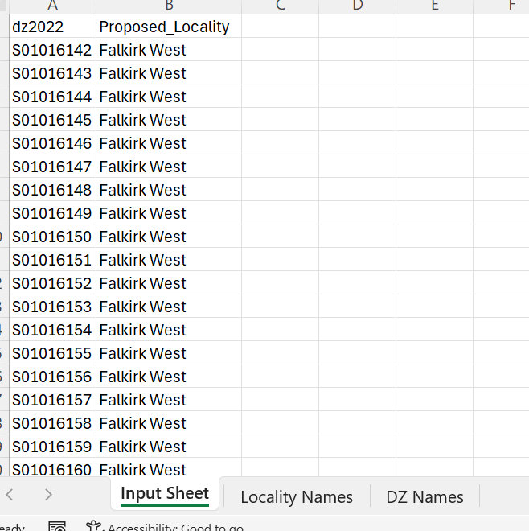
The second tab is called Locality Names. This tab is here to help you find the names of the localities that already exist in your area. Copy your locality names for the input sheet tab from here as the name match must be exact in order to compare your areas 2011 localities to your proposed 2022 localities.
The third tab is called DZ Names. This tab is here to help you find which 2022 datazones are in your area. This can be used to help make sure that you are not missing any datazones in your locality proposals or you can copy your areas DZ codes from here and fill out which localities they should belong to.
NOTE: In the input sheet tab make sure all DZ2022 codes have no blank spaces after them as this could cause issues in the code.
NOTE: You can propose completely new localities e.g. if one locality is now spliiting in two and the code is able to handle this. Just name them whatever you would like in the input sheet and they will appear on the map and table
Running The Shiny App
To run the shiny app go to your copy of the code and click on the ui.R file.
(If you are using a GitHub clone make sure you are in the project by clicking on )
When you click on the ui.R file a little button should pop up above you code which says Run App. If this does not appear make sure you have all required packages installed
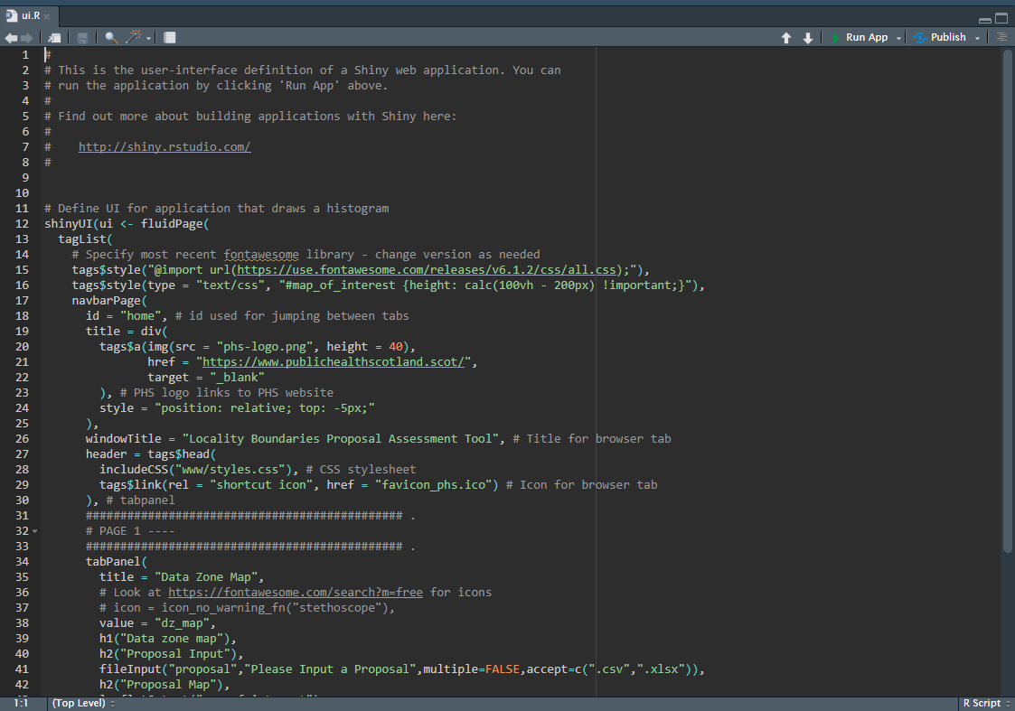
When you click on this the following window should pop up (this may take a minute or two)
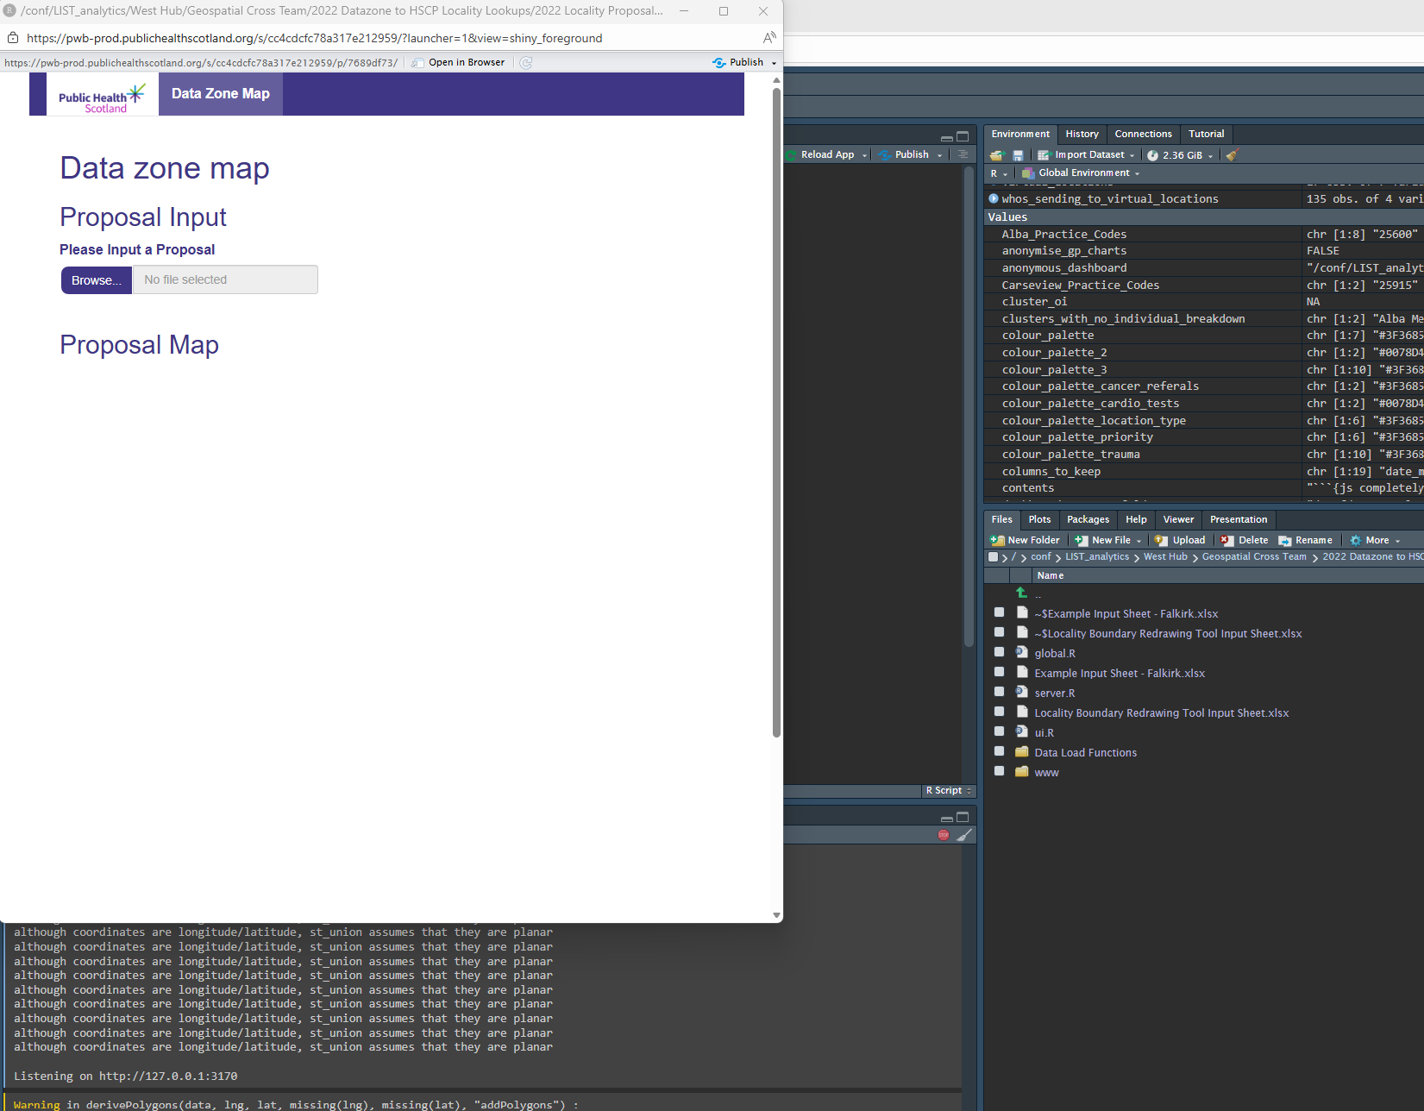
Now click on the Browse… button. A file explorer tab should pop up. Navigate to your filled in input sheet and double click on it. Once this file has loaded in, a map should appear. (This may take a few minutes).
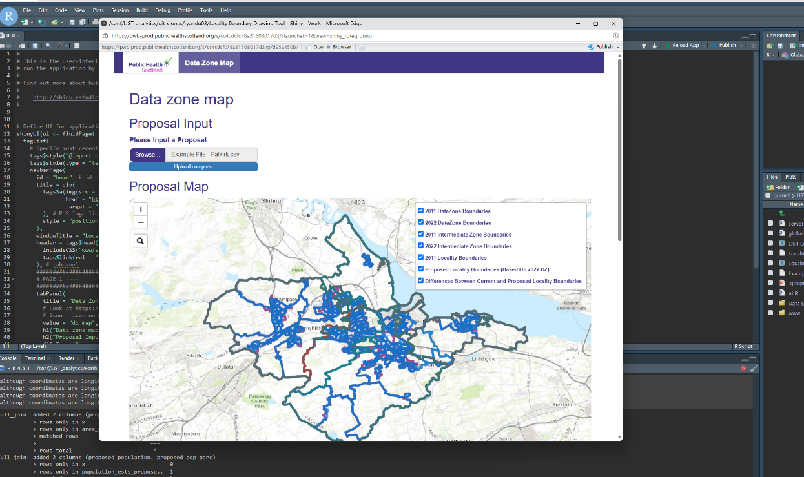
On the map there are 7 options which you can toggle between. The map can display the 2011 or 2022 DZ boundaries, 2011 or 2022 Intermediate Zone Boundaries, the 2011 best-fit locality boundaries, your new proposed best-fit locality boundaries based on 2022 datazones and then the final option which shows the difference between the old 2011 boundaries and your new proposal.
The tool also shows the differences between the old 2011 locality boundaries and your new proposed 2022 locality boundaries. It shows the difference in population and surface area. These areas and populations are shown as totals as well as percentages of the whole HSCP. 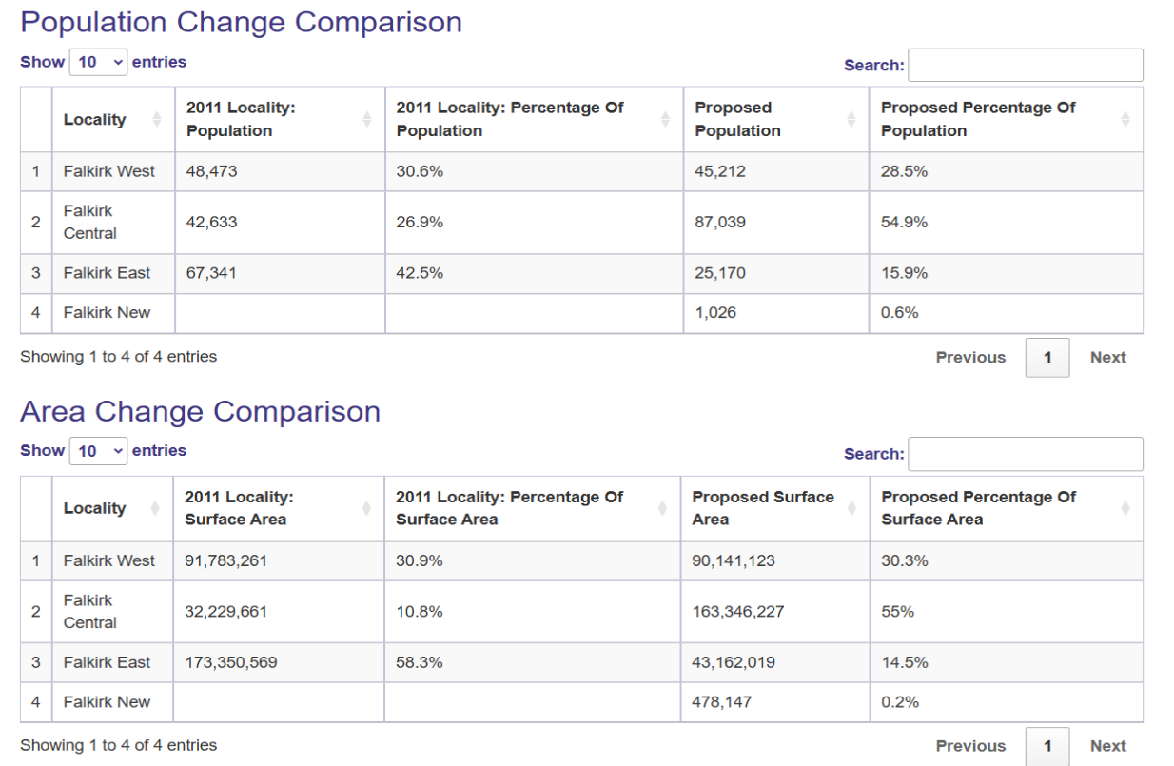

Contact
If you find any issues with the code please contact the LIST Geospatial team. If you have any questions about creation of best fit localities and the process of submitting your final proposals, please contact David Readhead.

